MongoDB Replica Sets

Markus Veijola

Opiframe Oy

What are replica sets?

A replica set in MongoDB is a group of mongod processes that maintain the same data set. Replica sets provide redundancy and high availability, and are the basis for all production deployments.
For short replica sets are for backing up our database data in different machines. Usually if you have user insensitive data, the data must be stored and replicated in many places for safety reason. Think if you lost all your client data, if your only database get corrupted, or the disk where the data resides gets broken. Also replica set makes sure, if one server goes down, there are others to serve clients.
There are primary and secondary replications, where primary accepts all read and write operations from clients. The primary records all the changes in data in oplogs (operational log) that is a special capped collection to keep track of data changes and modifications. The secondary members then copy and apply these operations in an asynchronous process. All replica set members contain a copy of the oplog, in the local.oplog.rs collection, which allows them to maintain the current state of the database. In replica sets there are minimum 2 and maximum of 12 mongod instances can exist.
In replica set, if primary server goes down due to network error or other servers in replica sets not able to reach to primary server or primary become unresponsive then internally by all servers election mechanism is triggered to elect new primary server and all this is very automatic.

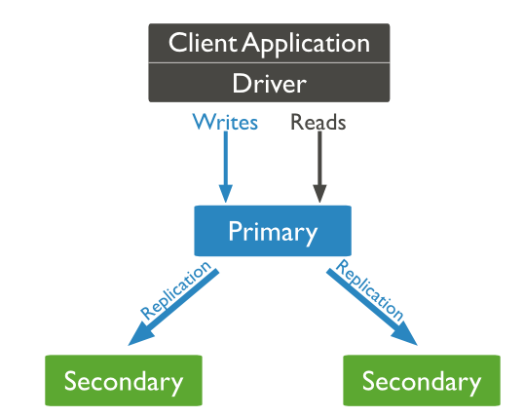

Benefits and features of replica sets
- To keep your data safe
- High (24*7) availability of data
- Disaster Recovery
- No downtime for maintenance (like backups)
- Read scaling (extra copies to read from)
- Replica set is transparent to the application
- A cluster of N nodes
- Any node can be primary
- All write operations goes to primary
- Automatic failover
- Automatic Recovery
- Consensus election of primary

Setting up an replica set

The next example builds an replica set in the local machine. You can use the very same technique to build a replica set where mongod instances are distributed in different data centers.

The next example will convert standalone mongod instance to a replica set.
When you start to set up replica set you start your mongod instance with option –replSet as in example below:
mongod --port "PORT" --dbpath "YOUR_DB_DATA_PATH" --replSet "REPLICA_SET_INSTANCE_NAME"

example…

mongod --port 27017 --dbpath "C:\data\db" --replSet rs0

Now that your mongod is running, start the mongo Shell to set up secondary instances in your replica set.

When dealing with replica sets you have a global variable called rs in use. Using this variable you can add, remove mongod instances from your set. Before ANYTHING you need to initiate your replica set with command rs.initiate()…this can take some time. When initiate is over you should see, that command prompt has changed to something like this: rs0:OTHER>

Now run next command rs.status() or db.isMaster() and you should see that the running instance of mongod is set as an primary in your set….

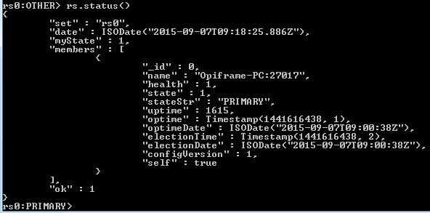

Now that you have primary server running you can start to add “slaves” or secondary server instances in your set.
This is done by calling a function rs.add() that has a following signature:

rs.add(HOST_NAME:port)

example

rs.add(“secondary1.net:27017”);

In our example case we will add three secondary servers in host: localhost in ports 27020,27021,27022. The different ports must be defined, because in our example all the servers are running in same machine.
Before you can add the server in you set IT MUST BE running. To start the second server define it as next… (Note that you must have a folder rs0_instance1 in your c drive before executing the command. Note also that EACH mongod instance MUST have it own folder for database)

mongod –port 27020 –dbpath “C:\rs0_instance1” –replSet rs0

//And the rest two
mongod –port 27021 –dbpath “C:\rs0_instance2” –replSet rs0
mongod –port 27022 –dbpath “C:\rs0_instance3” –replSet rs0

After instances are running just add them to your set…Note that these command must be run from mongo Shell that is connected to PRIMARY server!

rs.add(“Opiframe-PC:27020”);
rs.add(“Opiframe-PC:27021”);
rs.add(“Opiframe-PC:27022”);

After adding all secondary servers run the rs.status() to see that the stateStr for secondary servers are SECONDARY, otherwise the servers are not ready yet.

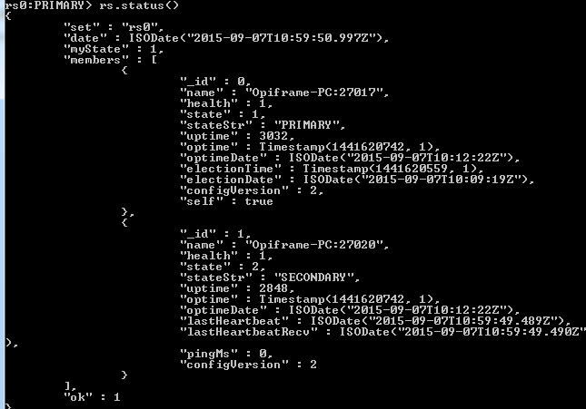

Testing the replica set

To test the replica set you should have a database with some collection and documents in it. The idea is to test read/writes and see that the data is replicated from primary server to secondary’s. Also we want to test situation where the primary server drops down, and verify that some of the secondary’s becomes a primary.

To test the replica set, use some collection in from your primary server, i.e. use students.

Make a query for database to see that there is data. Now connect to a secondery server with next commands…

conn = new Mongo(“Host:Port”);
//example
conn = new Mongo(“Opiframe-PC:27020”);

After you see that connection was successful switch to students (or some other) database.

dbTest = conn.getDB(“students”);

Now try to make a query with command:

dbTest.coll.find()

You should see next error appear, because direct reads from client IS NOT allowed to secondary servers

error: { "$err" : "not master and slaveOk=false", "code" : 13435 }

But read and test the data from secondary server you can set the “read flag” for this purpose using command:

conn.setSlaveOk()

Now try to make a query again and see that it works.

Next we test the situation where primary server goes offline to see that some of the secondary’s will cover that. To shutdown primary you can just close the CMD running the primary, or from mongo shell give the next command (check that mongo Shell is connected to primary server…you can see it that command prompt is rs0:PRIMARY>)

db.adminCommand({shutdown:1});

Now open mongo to server Opiframe-PC:27020 with next command:

mongo –port 27020 –host “Opiframe-PC”

Check the status with command rs.status() to see which secondary’s has get the primary status:

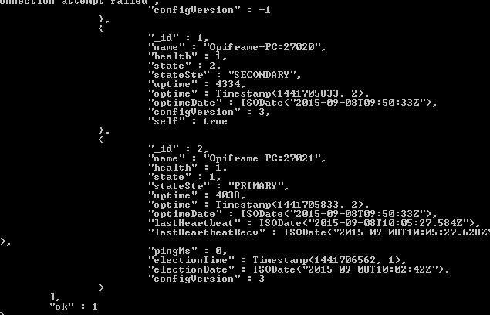

Exercise

Create a replication set cluster with one primary and five secondary servers. Test that the data is replicated to all servers. Test also that if primary drops, then some other server becomes a primary. Test what happens if there are only two servers running. Which one of them is primary? What if there is only one server running that was previously a secondary server?

